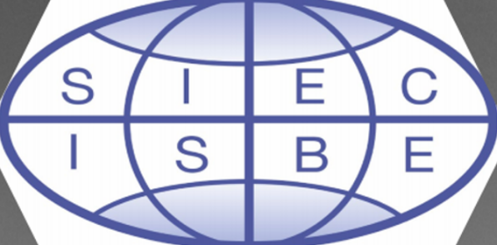

SIEC-ISBE International
Call for Research Proposals
for Presentation at the
Spring 2024 Online Research Symposium

The SIEC-ISBE International Mission enhances the international perspective of business and business education professionals. We do this by providing international educational and networking opportunities. One of our priorities is to support business education researchers by offering a platform to present research in progress and receive feedback from business education faculty.
The Executive Committee invites submissions of conceptual papers, empirical studies, and student research projects related to business education. Areas of interest include, but are not limited to, the following topics:
- Leadership in business education
- Pedagogical practices
- Using Generative AI to enhance teaching and learning
- Ethical use of technology in teaching and learning
- Discipline-specific topics related to business and business education
Submissions for this symposium are due by January 15, 2024.
If you are interested in submitting a research manuscript (works in progress) that has yet to be published, please send your abstract via the online submission system link here.
Accepted proposals will be notified by February 1, 2024. The Symposium will occur on March 1, 2024, at 9:00 a.m. Central Standard Time.

